Experiment 2

Remote Method Innovation Method

Name: Sai Harsha Vardhan AVN

Roll-no: BCSE1823

Batch: ‘A’

**Aim**: Write a Java program for Remote method Invocation.

**Theory:**

RMI stands for **Remote Method Invocation**. It is a mechanism that allows an object residing in one system (JVM) to access/invoke an object running on another JVM.

Architecture of an RMI Application

In an RMI application, we write two programs, a **server program** (resides on the server) and a **client program** (resides on the client).

* Inside the server program, a remote object is created and reference of that object is made available for the client (using the registry).
* The client program requests the remote objects on the server and tries to invoke its methods.

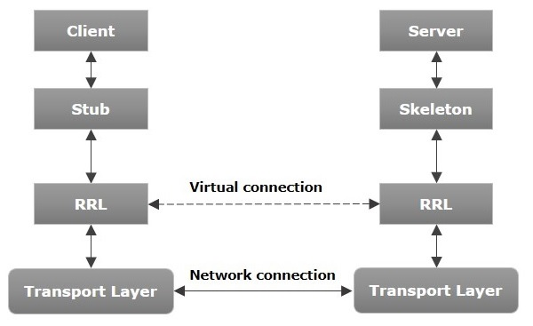

## Working of an RMI Application

## The following points summarize how an RMI application works −

* When the client makes a call to the remote object, it is received by the stub which eventually passes this request to the RRL.
* When the client-side RRL receives the request, it invokes a method called **invoke()** of the object **remoteRef**. It passes the request to the RRL on the server side.
* The RRL on the server side passes the request to the Skeleton (proxy on the server) which finally invokes the required object on the server.
* The result is passed all the way back to the client.

## RMI Registry

RMI registry is a namespace on which all server objects are placed. Each time the server creates an object, it registers this object with the RMIregistry (using **bind()** or **reBind()** methods). These are registered using a unique name known as **bind name**.

To invoke a remote object, the client needs a reference of that object. At that time, the client fetches the object from the registry using its bind name (using **lookup()** method).

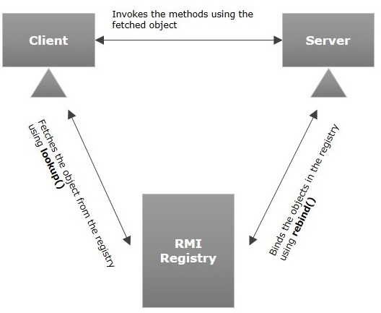

Goals of RMI

Following are the goals of RMI −

* To minimize the complexity of the application.
* To preserve type safety.
* Distributed garbage collection.
* Minimize the difference between working with local and remote objects.

**Code**:

1. *Message-code*:

import java.rmi.*;

import java.rmi.RemoteException;

public interface Hello extends Remote{

void printMsg() throws RemoteException;

int adder(int x,int y)throws RemoteException;

}

1. *Server-code*:

import java.rmi.registry.Registry;

import java.rmi.registry.LocateRegistry;

import java.rmi.RemoteException;

import java.rmi.server.UnicastRemoteObject;

public class Server extends UnicastRemoteObject implements Hello{

public Server() throws RemoteException{}

@Override

public void printMsg() throws RemoteException {

System.out.println("This is an example RMI program"); //To change body of generated methods, choose Tools | Templates.

}

@Override

public int adder(int x, int y) throws RemoteException {

return(x+y);

}

public static void main(String agrgs[]){

try{

Registry registry = LocateRegistry.createRegistry(8000);

registry.rebind("Hello server",new Server());

System.out.println("Server Ready");

}catch(Exception ex){

System.out.println("Server Exception:"+ex.toString());

ex.printStackTrace();

}

}

}

1. *Client-code*:

import java.rmi.registry.LocateRegistry;

import java.rmi.registry.Registry;

import java.rmi.RemoteException;

import java.rmi.NotBoundException;

import java.util.Scanner;

public class Client {

private Client() {}

public static void main(String[] args) throws RemoteException,NotBoundException {

Client c = new Client();

c.connectRemote();

}

private void connectRemote() throws RemoteException, NotBoundException {

try {

Registry registry = LocateRegistry.getRegistry("Localhost",8000);

Hello h = (Hello)registry.lookup("Hello server");

System.out.println("In client");

h.printMsg();

Scanner sc = new Scanner(System.in);

System.out.println("Enter two integer values");

int a = sc.nextInt();

int b = sc.nextInt();

System.out.println("Sum is: "+h.adder(a,b));

}

catch(RemoteException e){

System.out.println("Exception: "+e);

} } }

**Output**:

1. First, we need to compile all the files.
2. Then run the server-code, After starting the server you can see the message in the output screen as “server Ready”..

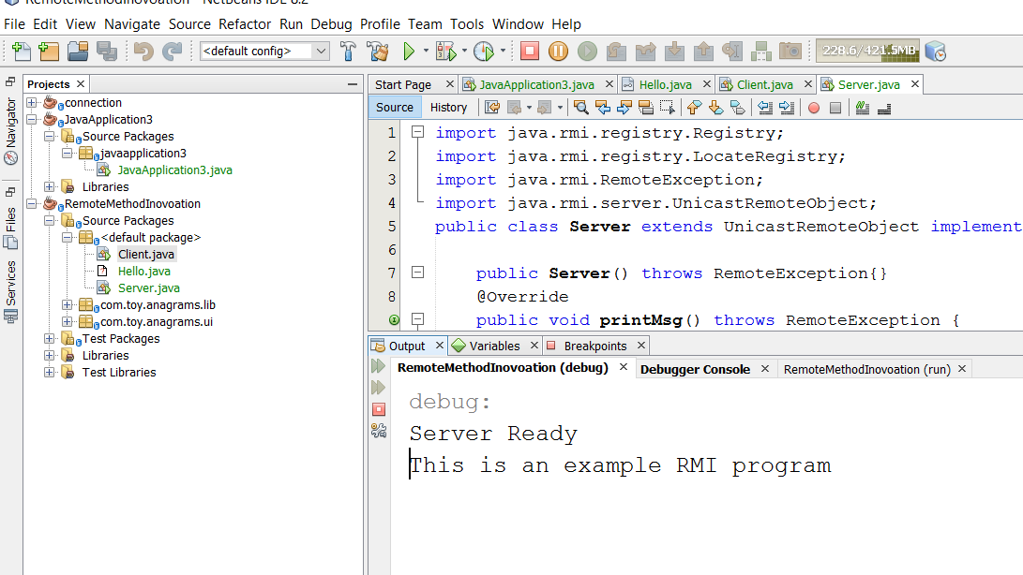

1. Now, run the client-code. And you can enter the values of the variables so, that it will add both the values.

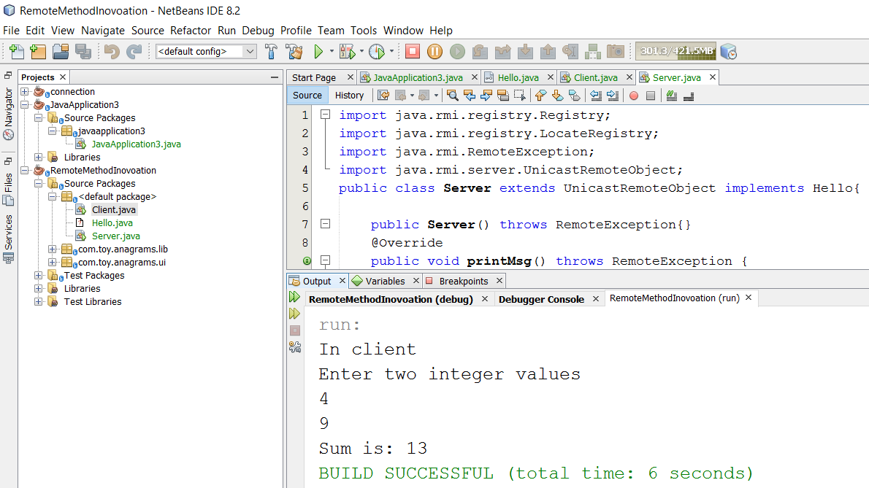

**Conclusion**: The Remote Method Invocation program is implemented successfully.